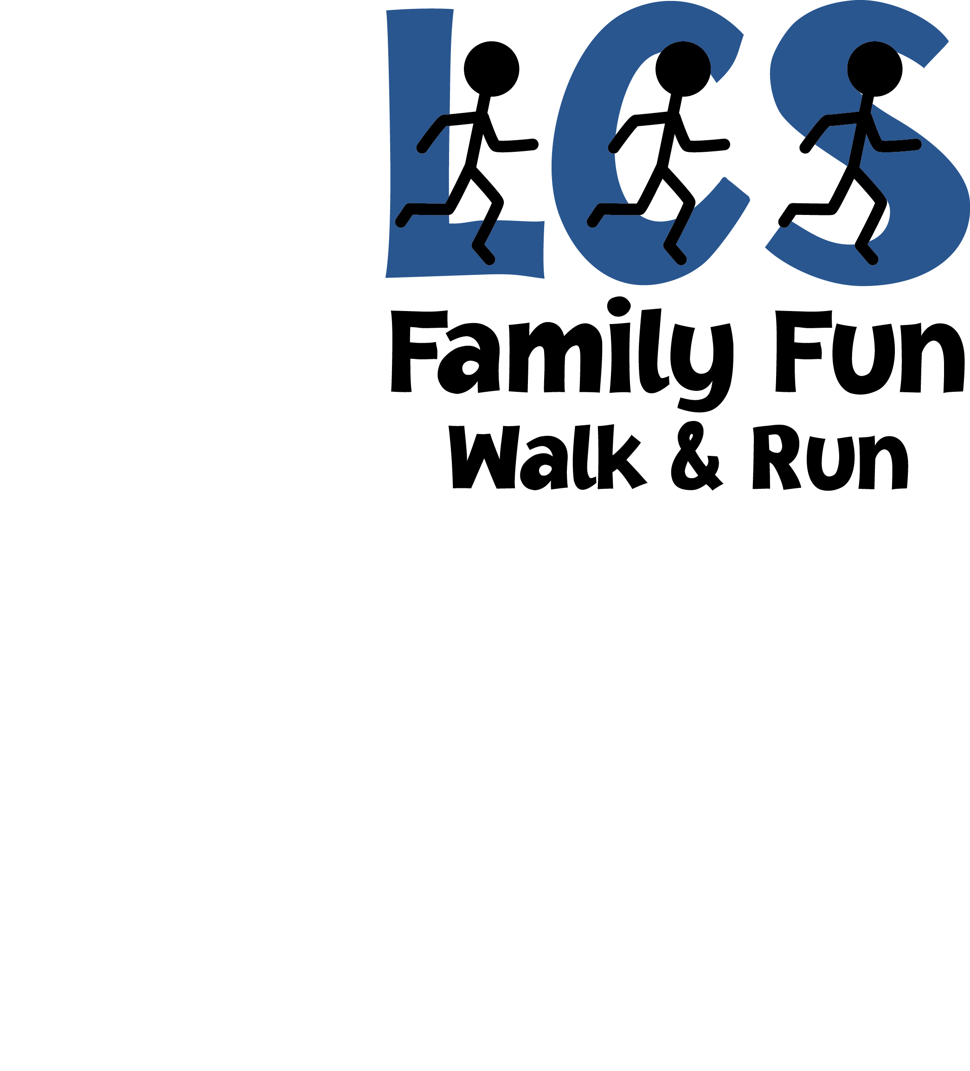

**Saturday, April 6, 2013**

**At Harry Dunham Park**

[](http://www.google.com/url?sa=i&rct=j&q=running+people&source=images&cd=&cad=rja&docid=l_-hPt37vKdWnM&tbnid=wVm89NvTw6Fk3M:&ved=0CAUQjRw&url=http://joseepoirier.blogspot.com/2012/02/21-habits-of-happy-people.html&ei=HUMNUYqkEMa60AH7h4DIBA&bvm=bv.41867550,d.dmQ&psig=AFQjCNFt2IaRdlW1lZxDx2OyzJNqWaetcg&ust=1359910008985420)

**8:30 am: Registration and Number pick-up**

**9 am: 3.1(5k) mile run or walk**

***Rain or shine!***

**$5 for kids; $7 for adults**

**Siblings are welcome!**

Any questions, please contact Elda Feldman at [eldab@optimum.net](mailto:eldab@optimum.net) (973-941-3355 cell)

**LCS 3 Mile Fun Run and Walk Registration Form**

**Saturday, April 6th**

**Please register by Monday, March 25th**

**LAST Name**________________________________________________________________

**Home Phone**____________________ **Cell Phone**__________________________________

**Email** ______________________________________________________________

**Participants**:

**Name** **Age/Grade**

____________________________________________ __________

____________________________________________ __________

____________________________________________ __________

____________________________________________ __________

____________________________________________ __________

____________________________________________ __________

____________________________________________ __________

**$5 for kids; $7 for adults**

**Total $ for all participants in your family:** _________

**Release and waiver (Please read and sign)**

I understand that there may be health risks associated with running. I certify that I and the people listed above are capable of running in this race and understand that I should not enter and run unless I and all of those listed above, are medically stable and properly trained. I, along with the above listed, also assume any other risks associated with running this event including, but not limited to, falls, contact with other participants, and the effects of weather and conditions. Knowing these facts and in consideration of your acceptance of my entry, I hereby for myself, my heirs, executors, administrators, or anyone else who might sue on my behalf covenant not to sue, and waive, release, and discharge the sponsors or contributors to this event, the school, any race officials, volunteers, the city and police agencies, their representatives successors or assignees from any and all claims of liability for death, personal injury, or property damage of any kind or nature whatsoever arising out of, or in the course of my participation. The release form and waiver extends to all claims of every kind or nature whatsoever, foreseen and unforeseen, known and unknown. Minors will be accepted with a parent’s signature.

________________________________________ _________________

Signature Date